508 Implementation
Contents
INTRODUCTION 4
CATEGORIES 4
ALT IMAGES 4
Dropdowns icons 5
Filter icons 5
Calendar icons 6
Logo 6
Chart images 7
Saving data 7
View Icon 8
Disabled View Icon 8
Edit Icon 8
Disable Edit Icon 9
Collapse Icon 9
Expand Icons 9
Indicator Icons 10
Rest of images in the application 10
TAB CONTROL (CALENDARS) 11
LANGUAGE ATTRIBUTE MISSING 13
TABLE HEADER CONTAINS NO TEXT 13
Tables 14
Batch entry section 14
Sections 15
Empty TH in the JSP 16
Checkboxes in header 17
MISSING FORM LABEL 17
Buttons 18
Missing titles 18
Filters 19
Checkboxes in first column 20
Varicella and tuberculosis 20
Chart in Home page 20
Titles in images 21
UNABLE TO TAB TO REPEATING BLOCK ICONS, TABLE ICONS AND ICONS IN GENERAL AND ENTER KEY 22
View/Edit/Delete table icons 22
Print / Export icons 23
Expand/Collapse icons 24
Icons not within links 24
Browse file 25
LOW CONTRAST 25
Useful tools 25
Section Names 26
Required fields 28
Disabled fields 29
Edit batch section 29
Blue headers 30
Updated documents (green text) 30
Condition in Page Details: 31
Conditions in Question Library 32
Disabled Return link 32
Other colors 32
Green color on Patient file 32
Section name in Case Report document 33
MISSING FIRST LEVEL HEADING 34
MISSING TITLE 34
UNABLE TO TAB TO READ-ONLY TEXT 35
Expand/Collapse icons 35
Dashlet 35
Notices, News and disabled Queues 36
Queues in general 37
Submit Icon on home page 39
Headers 39
Patient file 40
View Investigation 41
Class Notab 41
Class tabIndexClass 41
INCONSISTENT COMBOBOX 42
EMPTY LINKS 42
Empty links in section 43
Empty link in page 43
TABLES LAYOUT 44
Regular tables 44
Tables generated from <layout:tabs> 44
ADDITIONAL FUNCTIONALITY 45

INTRODUCTION

This document walks you through different 508 issues found during the NBS Remediation plan spreadsheet. Since they are common issues across the system, different categories have been created. The resolution for some of the categories is a single fix across 1 or many pages, other categories may have different type of implementation in order to resolve all the different scenarios.
Going forward, new implementations should follow the rules applied to fix the following categories:

CATEGORIES

ALT IMAGES

Issue: Graph Image alternative text is not present. Each image must have an alt attribute. Without alternative text, the content of an image will not be available to screen reader users or when the image is unavailable
Solution: This section consists of adding an “Alt” attribute to each of the images. The attribute value should accurately and succinctly present the content and function of the image. If the content of the image is conveyed in the context or surroundings of the image, or if the image does not convey content or have a function, it should be given empty/null alternative text (alt="").

Dropdowns icons

This is a general fix. The SelectTag.java file from the library called struts-taglib-1.3.8.jar has been updated in order to add alt = “Choose option”.
Library | struts-taglib-1.3.8.jar
File | SelectTag.java
Code | added alt = “Choose option”

Filter icons

File | Each file containing icons representing filters
Code | added the corresponding alt according to the requirements below
Icon | The icon names are respectively:  - Combo_select-gif  - Filter.gif  - FilterAndSortAsc.gif  - FilterAndSortDesc.gif  - GraySortAsc.gif  - GraySortDesc.gif

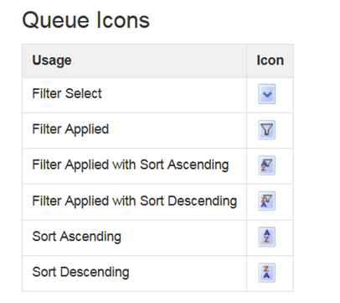

Calendar icons



File | Each file containing icons representing calendars
Code | alt = "Select a Date" to be consistent with PageBuilder pages.
Icon | Calendar.gif

Logo



Files | topnav.jsp and topnavfullscreenwidth.jsp
Code | Added alt="NBS Logo" to JSP pages
Icon | NedssLogo.jpg

Chart images
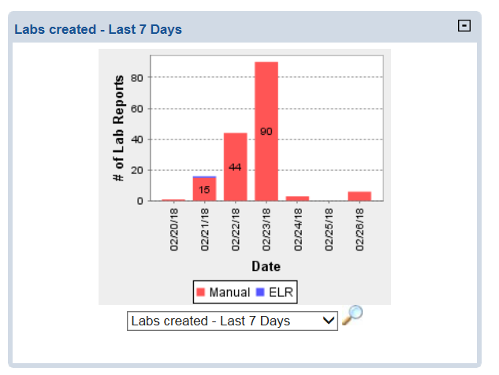
Files | Charts.jsp and charts.js
Code | The JSP file has been modified to include the alt for the image shown by default (Cases created – Last 7 Days) and the JavaScript file has been modified to update the value of the Alt depending on the option selected from the dropdown (Labs created – Last 7 Days”, “Cases Assigned - Last 7 Days”).

Saving data

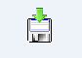

Files | each file containing the icon saving_data.gif
Code | alt="Saving data"
Icon | saving_data.gif

View Icon

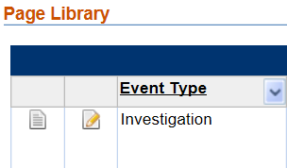

Files | Each file containing the icon page_white_text.gif
Code | Same value than “Title” or if there’s no title: title = “View” alt = “View”
Icon | page_white_text_disabled.gif

Disabled View Icon


Files | Each file containing the icon page_white_text_disabled.gif
Code | alt = “View disabled” or “View Question disabled” in case alt = “View Question disabled” was already there or not.
Icon | page_white_text_disabled.gif

Edit Icon



Files | Each file containing the icon page_white_edit.gif
Code | Same value than “Title” or if there’s no title: title = “Edit” alt = “Edit”
Icon | page_white_edit.gif

Disable Edit Icon

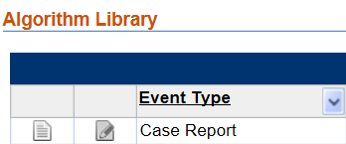
Files | Each file containing the icon page_white_edit_disabled.gif
Code | alt = “Edit disabled” or “Edit Question disabled” in case alt = “Edit Question disabled” was already there.
Icon | page_white_edit_disabled.gif

Collapse Icon

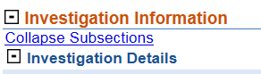

Files | Each file containing the icon minus_sign.gif or section_collapse.gif or CollapseAll.gif
Code | alt = “Collapse” / alt = “Collapse Block” / alt = “Collapse All Sections” or alt = “Collapse All Subsections”
Icon | minus_sign.gif / section_collapse.gif / CollapseAll.gif

Expand Icons

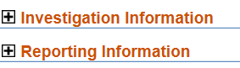

Files | Each file containing the icon minus_sign.gif
Code | alt = “Expand” / alt = “Expand Block” / alt = “Expand All Sections” or alt = “Expand All Subsections”
Icon | plus_sign.gif / section_expand.gif / ExpandAll.gif

Indicator Icons
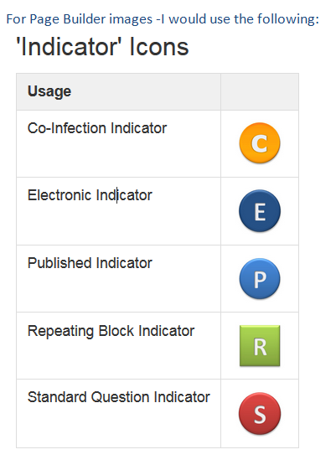
Files | Each file containing the corresponding indicator icon
Icon/Code | - Co-infection Indicator: Ind_CoinfectionQ_small.gif alt = “Co-infection Indicator”  - Electronic Indicator: ind_electronic.gif it has been changed to alt = “Electronic Indicator” (since eventually we will have other types of documents, and we don’t want to have to keep updating this tag.)  - Published Indicator: PublishedIcon.gif alt = “Published Indicator”  - Repeating Block: RepeatingBlock.gif alt="Repeating SubSection"  - Standard Question Indicator: StandardizedIcon.gif alt=”Standard Question Indicator”

Rest of images in the application

After updating all the <img> tags covered in the 508 Plan spreadsheet, all the images from the location: \source\gov\cdc\nedss\webapp\nbs\resource\image have been updated to include an alt with a valid description in case is necessary or alt=”” in case the image does not convey content (like Shim.gif, leaf.gif, etc).
Most of them already have a title, so the same alt was added.
In case none of the properties was presented, a new alt and title were added as it’s shown below:

Code | alt = “Close”
Icon | Close.gif


Code | alt = “Magnify”
Icon | Magnify.jpg


Code | alt = “Print Page”
Icon | Printer.gif/Printer_icon.gif


Code | alt = “Error”
Icon | tab_error.gif

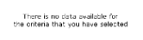
Code | alt="No data"
Icon | Nodata.gif

TAB CONTROL (CALENDARS)

Issue: Calendars were not accessible through tab key.
Solution: The first issue was calendars not getting the focus once the tab key is presented. After fixing that, the calendar got the focus but enter key was not opening the Calendar. These two features have been updated in order to be able to select a date using the keyboard.
Solution for giving the focus to the calendar:
Library | struts-taglib-1.3.8.jar
File | ImgTag.java
Code | Add tabIndex=”0” in order to get the focus

Solution for opening the calendar after the calendar gets the focus and the enter key is pressed:

File | Each file containing a calendar (calendar.gif)
Code | onkeypress=”showCalendarEnterKey('DEM115','DEM115DateIcon');”  or  onkeypress=”showCalendarFutureEnterKey('DEM115','DEM115DateIcon');”  DEM115 is an example, instead of that, we include the corresponding ids.

File | Globals.js
Code | /**  * showCalendarEnterKey(): show calendar using the enter key  */  function showCalendarEnterKey(id, id2, e)  {  if(document.activeElement!=null && document.activeElement.src.indexOf("calendar")!=-1){  if (e!=null && e.which=='13'){  getCalDate(id,id2);  return false;  }  }  }  /**  * showCalendarFutureEnterKey(): show calendar (future) using the enter key  */  function showCalendarFutureEnterKey(id, id2, e)  {  if(document.activeElement!=null && document.activeElement.src.indexOf("calendar")!=-1){  if (e!=null && e.which=='13'){  getCalDateFuture(id,id2);  return false;  }  }  }

One issue that was found during testing is disable calendars were getting the focus in Firefox and Chrome. For resolving it, the following solution was provided:
Files | Each file containing .find("img").attr("disabled", true); / .find("img").attr("disabled", false);
Code | Add .find("img").attr("tabIndex", “-1”); / .find("img").attr("tabIndex", “0”); respectively.

LANGUAGE ATTRIBUTE MISSING

Issue: The language of the document is not identified. Identifying the language of the page allows screen readers to read the content in the appropriate language. It also facilitates automatic translation of content

Solution:
Files | Each file containing the tag <html>
Icon/Code | - <html lang="en">  - <html lang=\"en\"> in case is a Java class the one that generates the tag

TABLE HEADER CONTAINS NO TEXT

Issue: Table header: A <th> (table header) contains no text. The <th> element helps associate table cells with the correct row/column headers. A <th> that contains no text may result in cells with missing or incorrect header information.
Solution: If the table cell is a header, provide text within the cell that describes the column or row. If the cell is not a header or must remain empty (such as the top-left cell in a data table), make the cell a <td> rather than a <th>. In case we cannot change the th to td, for example if we are using the <display:column> tag, then provide a hidden <p> within the title of the <display:column> tag.

Tables
Tables that are using the <display> tag will be modified in order to contain a valid header name, instead of changing the <th> to <td> because that would require changes to the library:
- If the column contains actions like Run, the title of the <display:column tag will contain a hidden p tag with a descriptive name. It won’t show in the UI and it will pass Wave requirements. That way the UI doesn’t change.
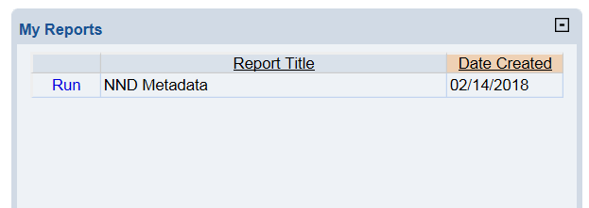

Files | MyReports.jsp (and any other file with a table created from the display tag with an action header empty and an action not represent by icons)
Code | <display:column title="<p style='display:none'>Action</p>"

Batch entry section

Batch entries are not created from the display tag. Instead, they are created using the regular table tags, like <tr>, <th>, <td. In this case, the empty <th> is changed to <td> and the inline styles are modified in order to look the same as the previous <th>:
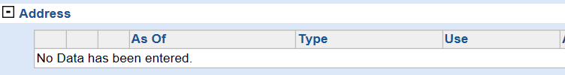

Files | Every file with batch entry
Code | Change <th> to <td> and add the following style = "background-color: #EFEFEF; border:1px solid #BBB"

Sections

There are cases where we have sections without subsections, like patient search:

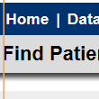
In this case an empty th is generated (because the nedss:container tag does not contain a name and displayImg = F). For resolving this issue and not affecting other parts in the system, the following solution (which is a global change and should fix every similar situation) has been provided:
Files | NedssContainerTag.java
Method | renderContainerElement
Code | add the following code:  if(displayImg!=null && (name==null || name=="")){  sb.append("<tr>");  sb.append("<td colspan=\"4\" >");  // end of subsection  sb.append("</td> </tr>");  }else{  // subsection header

Something similar happens with the blue bars, like in Patient Summary:

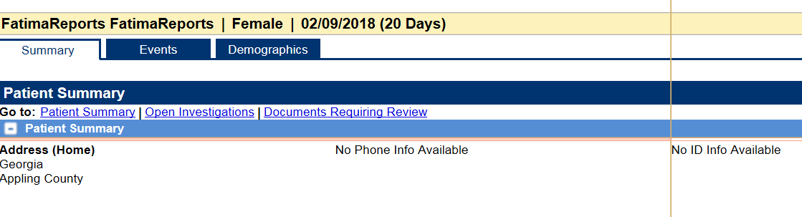
For resolving this, same solution has been provided but modifying a different file:

Files | BlueBarTag.java
Method | renderContainerElement
Code | add the following code:  if(displayImg!=null && (name==null || name=="")){  sb.append("<tr>");  sb.append("<td colspan=\"4\" >");  // end of subsection  sb.append("</td> </tr>");  }else{  // subsection header

Empty TH in the JSP

Changed to td, like find places:
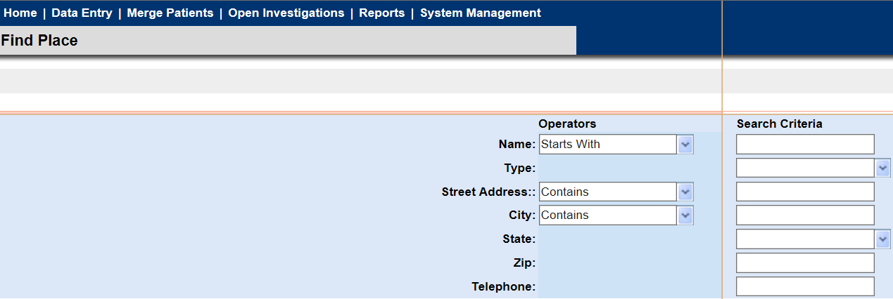

Checkboxes in header

This solution has been applied to columns with empty header but rows with checkboxes.
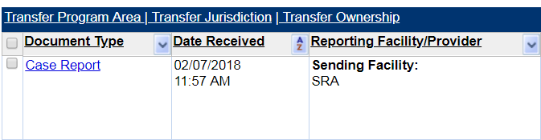

Files | Doc_needing_security_assgn.jsp/newreports_review.jsp
Code | First add a title to the checkbox: <input title='Select/Deselect All' type='checkbox'  Then Create a p with display=none: <display:column title=”<p style='display:none'>Select/Deselect All</p>”></display:column>

MISSING FORM LABEL

Issue: A form control does not have a corresponding label.
Solution: If a text label for a form control is visible, use the <label> element to associate it with its respective form control. If there is no visible label, provide an associated label, add a descriptive title attribute to the form control, or reference the label(s) using aria-labelled by. Labels are not required for image, submit, reset, button, or hidden form controls.
The issues under this category have been resolved adding a title. It was decided that the title must contain the label text associated to it in order to DNS to be able to find the input based on the title.

Buttons

As the previous description says, labels are not required for buttons. Some of the issues found in the application were related to buttons. This was happening because the type in the <input type=”button” was Button instead of button and it was not recognizing it as a button.

Files | Any file containing <button type = “Button
Code | Change it to <input type=”button”

Missing titles

Text inputs, single select, text areas, etc, have been modified to include the missing title.

Files | Any file containing <html:select without a title
Code | <html:select title="Name operator"

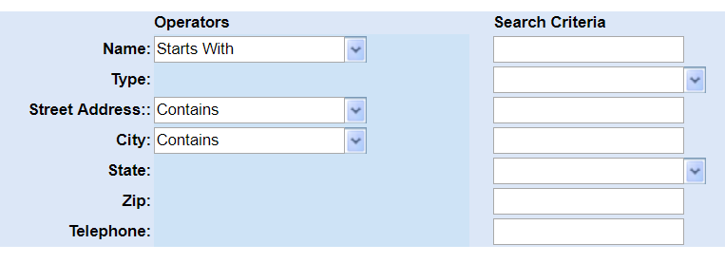

Files | Any file containing <html:text without a title
Code | <html:text title=”Enter a Name”

Filters

Label around OK/Cancel buttons in filter boxes was missing a text. That label is used as a container of OK and Cancel buttons. Same happens with Contains. In order to resolve that a hidden <p> tag has been included:

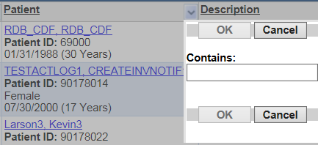

Files | jQueryMultiSelect.js
Code | <p style="display: none">OK/Cancel buttons</p> / <p style="display: none">Contains</p>

Checkboxes in first column

For example, DRSAQ and DRRQ contain checkboxes in the first column. All of them have been updated to include title="Select/Deselect checkbox”

Files | Doc_needding_security_assgn.jsp/newreports_review.jsp
Code | <input title="Select/Deselect checkbox"

Varicella and tuberculosis

For each of the question, use the label as the tooltip of the input/select box.
If the title was already there using the tooltip property, change it to label, otherwise DNS won’t recognize it because it might not contain the same text than the label.

Chart in Home page
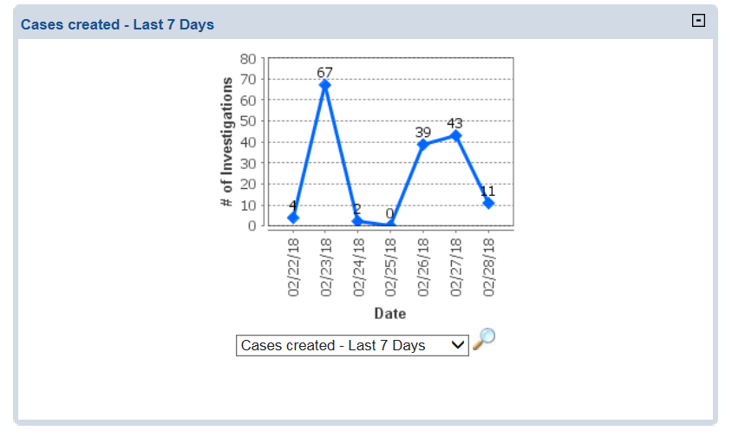

Cases creates dropdown: title= Select the chart to display.

Titles in images

Titles in images is not required by 508 but we have added some of them, like:

Collapse Icon

Indicator Icons
Files | Each file containing the corresponding indicator icon
Icon/Code | - Co-infection Indicator: Ind_CoinfectionQ_small.gif alt/title = Co-infection Indicator  - Electronic Indicator: ind_electronic.gif it has been changed to Electronic Indicator (since eventually we will have other types of documents, and we don’t want to have to keep updating this tag.)  - Published Indicator: PublishedIcon.gif, alt/title = Published Indicator  - Repeating Block: RepeatingBlock -> title="Repeating SubSection"  - Standard Question Indicator: StandardizedIcon: Standard Question Indicator

Titles to other images not addresses in the Remediation plan

This is not required by 508.
The remaining <img not covered in the 508 Plan have been addressed:
- Close.gif: alt = “Close”
- Magnify.jpg: alt = “Magnify”
- Next.gif / previous.gif: alt = “Previous” and alt = “Next”
- Shim.gif (alt = “”) because it does not convey to content, it is part of calendars.
- Rest of images used within the application (added alt and title)
img src="leaf.gif" alt="" title=""
Printer.gif/Printer_icon: Print Page
tab_error.gif: Error

Note: if there’s an existing ALT and missing TITLE, the value of the TITLE = ALT
Nodata.gif: alt="No data" title = "No data"

UNABLE TO TAB TO REPEATING BLOCK ICONS, TABLE ICONS AND ICONS IN GENERAL AND ENTER KEY

Issue: tabbing through a repeating block, the icons were not getting the focus.
Solution: add tabIndex=”0”. Same solution was applied to Calendars.

View/Edit/Delete table icons

View, Edit and Delete icons were inaccessible using tab key. In order to fix this, the attribute tabIndex=”0” has been added to each of the images.
Files | Any file containing View, Edit or Delete icons
Code | src="page_white_edit.gif" or src=\"page_white_edit.gif\" to  src="page_white_edit.gif" tabIndex="0" or src=\"page_white_edit.gif\" tabIndex=\"0\"  src="page_white_text.gif" or src=\"page_white_text.gif\" to  src="page_white_text.gif" tabIndex="0" or src=\"page_white_text.gif\" tabIndex=\"0\"  src="cross.gif" tabIndex="0" or src=\"cross.gif\" tabIndex=\"0\" to  src="cross.gif" tabIndex="0" tabIndex=”0” or src=\"cross.gif\" tabIndex=\"0\"

Sometimes the image is inside a link. In that case we will tab twice to the same element. For resolving this, additional functionality has been created in order to remove the tabIndex from the image:

Globals.js

function removeTabIndexFromImagesInsideLinks(){
var i=0;

var links = document.getElementsByTagName("a");

for (i=0; i<links.length; i++){

var images = links[i].getElementsByTagName("img");

if(images!=null && images.length>0){
var j=0;

for( j=0; j<images.length;j++){

images[j].removeAttribute("tabIndex");

}
}

}

}

topNavFulLScreenWidth.jsp

function startCountdown() {
var sessionTimeout = <%= request.getSession().getMaxInactiveInterval()%>
min = sessionTimeout / 60;
sec = 0;
getTimerCountDown();

addTabIndexToCells();
removeTabIndexFromImagesInsideLinks();
}

Print / Export icons

Tab to icons
In order to be able to tab to Print/Export icons, the tabIndex=”0” attribute has been added to each of the icons
Files | Each file containing print.gif/export.gif icons
Code | tabIndex=”0”

Enter key
In order to be able to print/export when enter key is pressed, the following code has been updated:
Files | Each file containing print.gif/export.gif icons
Code | Print: onkeypress="if(isEnterKey(event)) printQueue();"  Export: onkeypress="if(isEnterKey(event)) exportQueue();"

Files | Globals.js
Code | New function created:  function isEnterKey(e){  if((event!=null && event.keyCode=='13') || (e!=null && e.which=='13')){  return true;  }  else  return false;  }

Expand/Collapse icons
Update each tabIndex=-1 to tabIndex=“0” on links

Files | NEDSSContainerTag.java
Code | tabIndex=”0”

Icons not within links

In some cases, like page porting, the icons are not inside links (like in WDS). In this case, when the user clicks enter on the icon, the view functionality is not triggered. For resolving that, onkeypress event has been added:
Files | ManagePortPage
Code | onkeypress="if(isEnterKey(event)) //add here the same method called from onclick

Browse file

Browse button to select a file from the system doesn’t work if Enter key has been pressed. In order to resolve this, onkeypress = “this.click();” has been added to the code.
Files | PortPage.jsp, ContactAttachment.jsp, DSMLibrary.jsp, AttachImport.jsp, ManageTemplateLibrary.jsp, InvestigationAttachment.jsp.
Code | <html:file onkeypress="this.click();" title="Choose file" name="portPageForm" property="importFile" styleId="importFile" style="height: 1.8em;" maxlength="70" size= "70">

LOW CONTRAST

Issue: the contrast between the text and the background color should be a ratio of 3:1 (Large scale), 4.5:1 (AA), 7:1 (AAA). Using one of the tools, we have tried to apply ratios 4.5:1 or higher (AA).
Solution: The text and/or background color has been updated in order to meet the AA level. Some useful tools have been used in order to find the right color and to check in the ratio is the correct one.

Useful tools
For Contrast issues, there are a few useful tools that we can use:

- First of all, in order to pass the 3:1 ratio (A) for black background or 5:1 (AA) for white background, I used the following link to find similar colors to the ones we are using and resolving the low contrast issue:

https://www.w3.org/WAI/WCAG20/Techniques/working-examples/G183/link-contrast.html

- Using the following link (https://www.w3schools.com/colors/colors_picker.asp) there’s a tool to help us to pick lighter/darker colors to the one entered in the input box:
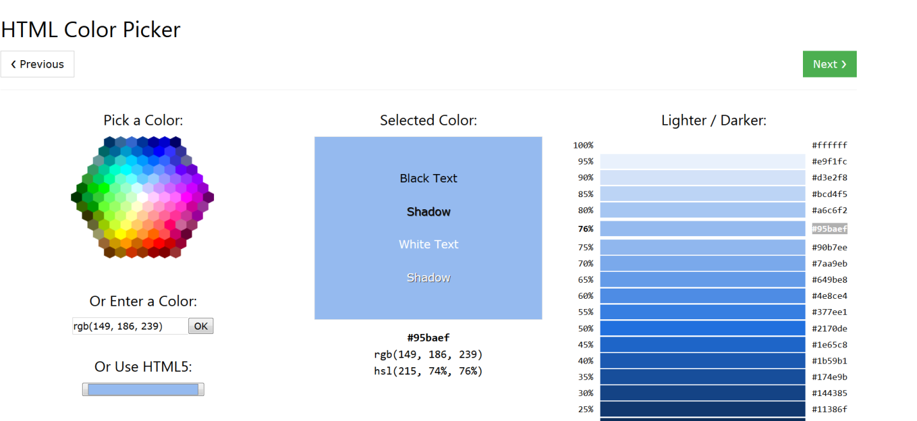

- Using this URL (http://www.msfw.com/Services/ContrastRatioCalculator) and entering the background color and the font color, it will tell you what the ratio is: 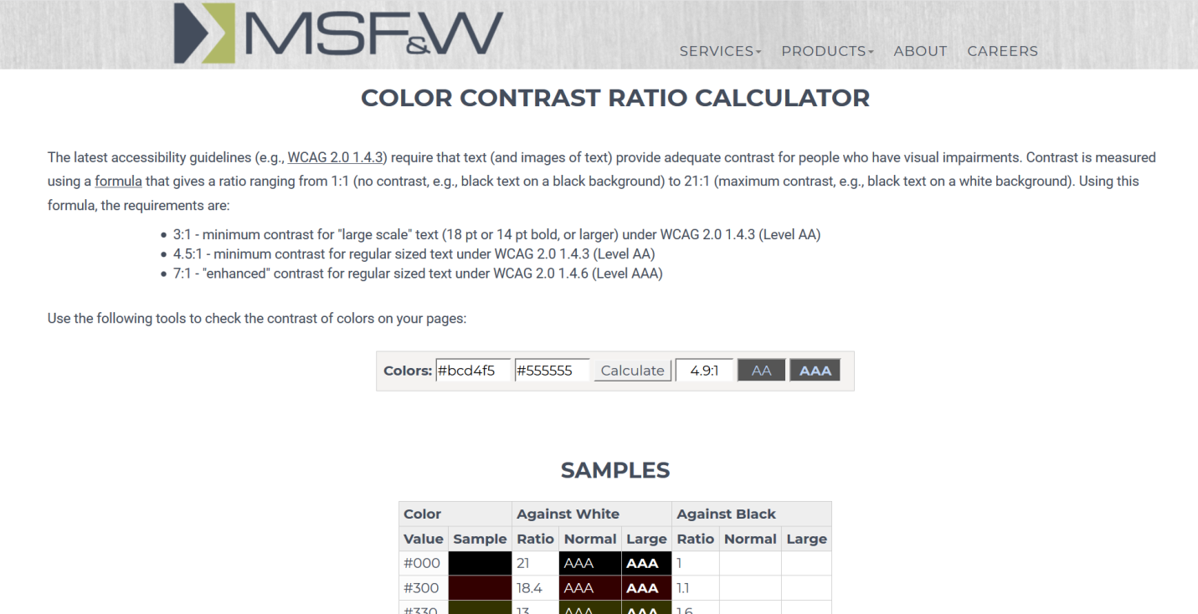

Section Names

- Updated the color from: #CC5200
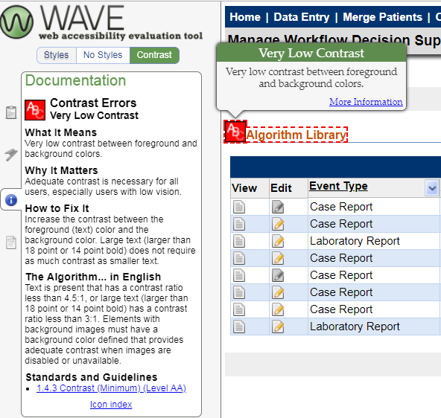

- To: #CC3300

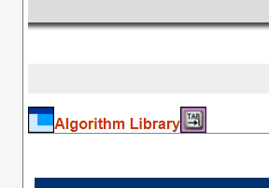

Files | Common.css
Code | div.sect h2.sectHeader a.anchor {text-decoration:none; /*color:#5F8DBF;*/ color:#CC3300}  div.sect table.sectHeader tr td.sectName a.anchor {text-decoration:none; /*color:#5F8DBF;*/ color:#CC3300}  div.bluebarsect h2.bluebarsectHeader a.anchor {text-decoration:none; /*color:#5F8DBF;*/ color:#CC3300}

Required fields

The red * in required fields.
- Updated the color from: red
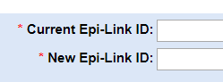

- To #CC0000

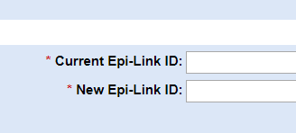
Files | Nedss.css
Code | .boldTenRed  {  font-size : 10pt;  font-family : Geneva, Arial, Helvetica, sans-serif;  font-weight : bold;  color : #CC0000;  }

Disabled fields

For example in WDS:
- Updated the color from: #BBB (or #808080)
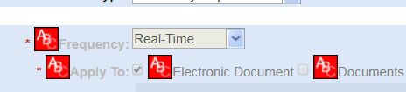

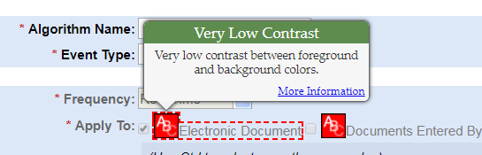

- To: #666666

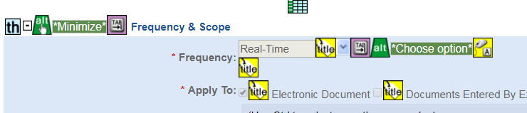

Edit batch section
Once we start editing any batch section, the background color changes. In this case, that color has been updated to meet the required level.
- Updated the color from: #95BAEF
- To #bcd4f5

Blue headers
- Updated the color from: #558ed5
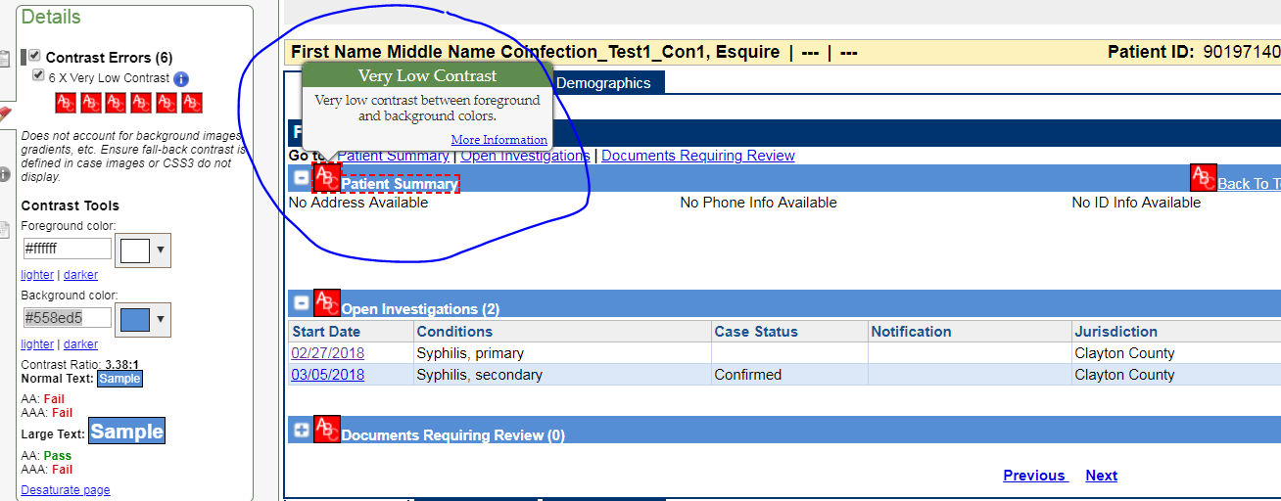

- To #2e6cb8

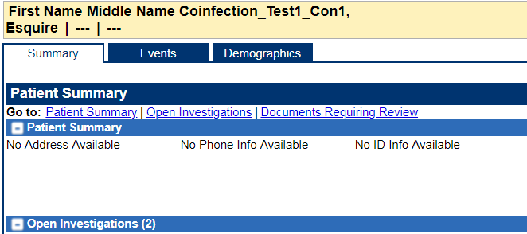

Updated documents (green text)

- Updated the color from: green (008800)
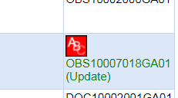
- To: #006600
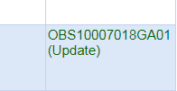

Condition in Page Details:
- Updated the color from: #FA5858
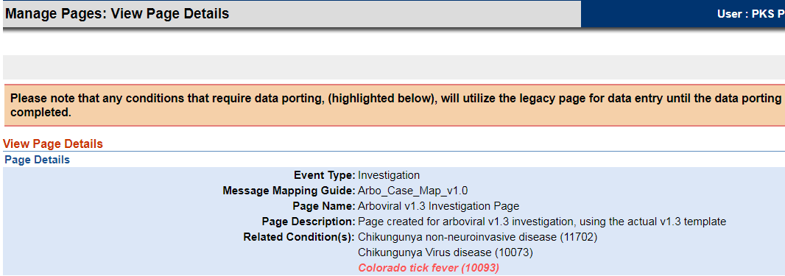
- To: #ad0505
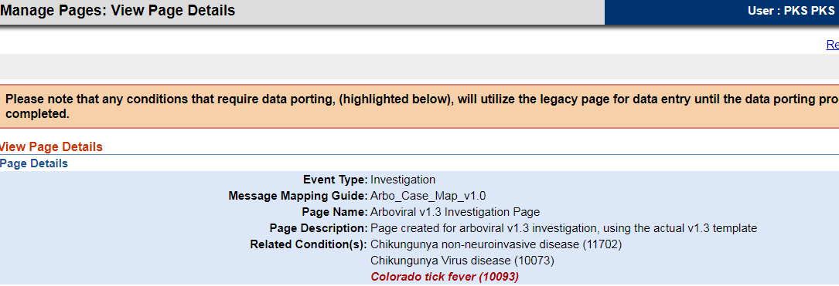

Conditions in Question Library

- Updated the color from: #D57100
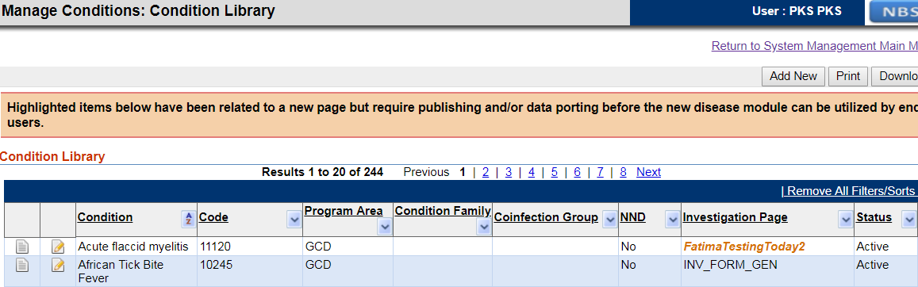
- To: #b35f00
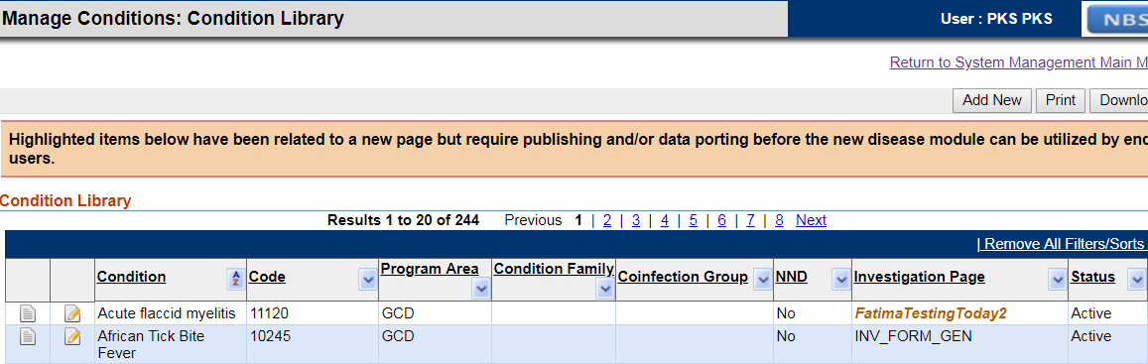

Disabled Return link
For example, in manage trigger Codes, once view button has been clicked, some functionality is disabled, like the Return to System Management Main Menu link.
From grey #808080 to #737373 (because the background color is white)

Other colors

From #CEE3F6 To: #d1e5f6

Green color on Patient file

For resolving this issue the color green (#008000) has been updated to #006000

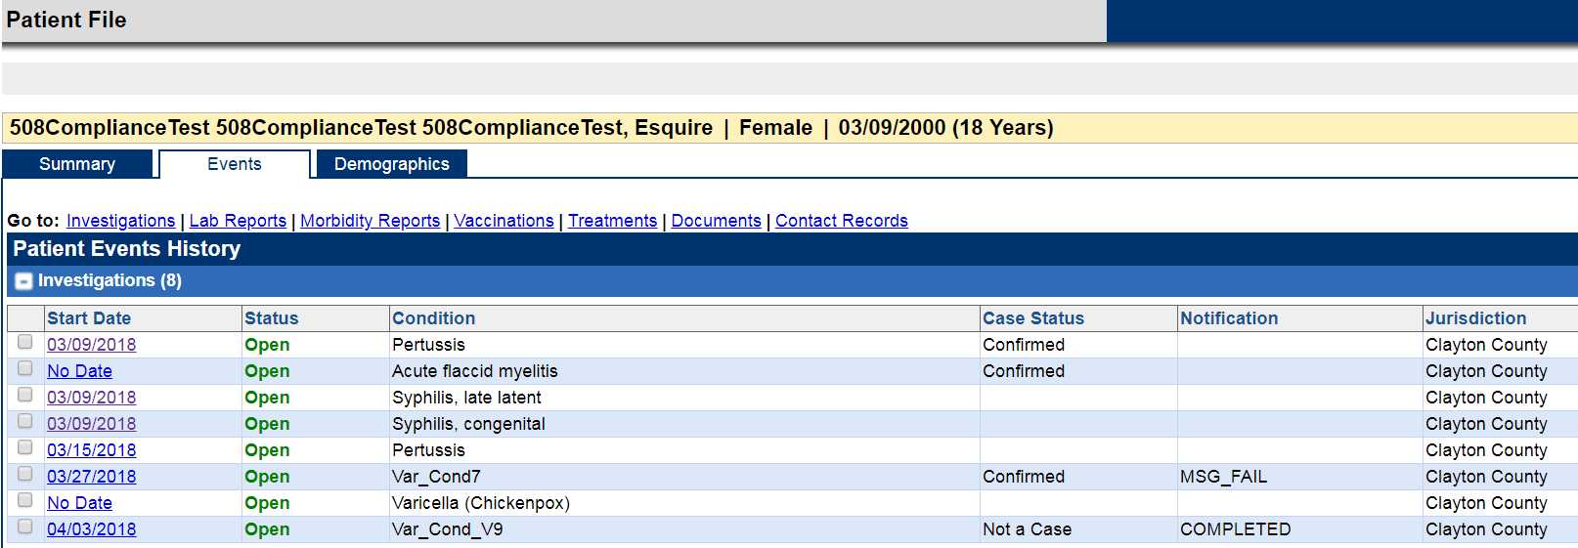

Files | WorkupLoad.java
Code | Change the red code by the green code:  String status = "<b><font color=\"green\">Open</font></b>";  String status = "<b><font color=\"#006000\">Open</font></b>";

Section name in Case Report document

In order to fix this issue, the corresponding xsl files under C:\SVN\NBS 5.4\source\PropertyFiles have been updated to change the color from #df9f61 to #a46322 (if the text is not big enough, change it to: #a46322). These files need to be updated in the NBS_DOCUMENT table. For that, new scripts have been added to SVN in SQL and Oracle

Files | ELR.xsl, PHCR_Legacy.xsl, PHDC.xsl, PHDC_TRMT.xsl  05_5.4_Migrate_ODSE.sql and 05_5.4_Migrate_ODSE_Val.sql (Sql and Oracle)
Code | Change color from #df9f61 to #a46322

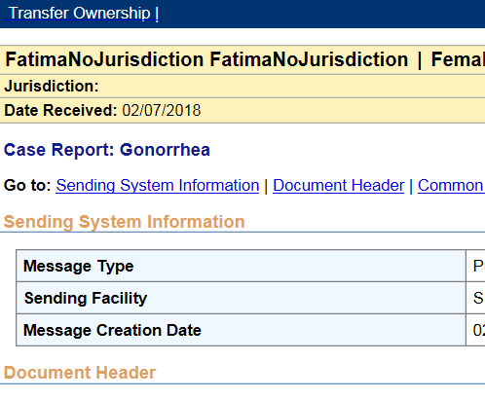
to #a96623

MISSING FIRST LEVEL HEADING

Added a <H1> tag containing the existing “header” represented by a table. This table has the class nedssPageHeaderAndLogoTable:

Files | TopNavFullScreenWidth.jsp / popupPageTitle.jsp
Code | <h1 class="pageHeader" style="padding: 0px; margin: 0px; font-size: 13px;"> <table class="nedssPageHeaderAndLogoTable">

MISSING TITLE
Add title to the page:
<title>Your title here</title>

UNABLE TO TAB TO READ-ONLY TEXT

ALL THE CHANGES DONE IN THIS CATEGORY REGARDING TO ADD TABINDEX=0 TO TEXT HAVE BEEN REMOVED AFTER CDC FEEDBACK. WE SHOULD NOT BE ABLE TO TAB TO READ-ONLY TEXT FORCING WITH TABINDEX=”0”. IMAGES, LINKS, ETC, GET THE FOCUS BY DEFAULT. THE TEXT DOESN’T NEED TO GET THE FOCUS. IN SOME CASES, ELEMENTS THAT SHOULD BE GETTING THE FOCUS, LIKE LINKS, ARE NOT GETTING IT BECAUSE THERE WAS A TABINDEX=-1 IN THE CODE. IN THAT CASE, THE ISSUE HAS BEEN FIXED. PLEASE, DISREGARD ANY CHANGE TO ADD TABINDEX=0 TO READ ONLY TEXT.
Issue: read-only text like information within tables which are not links are not read because the user cannot tab through them.
Solution: Issues on this category have been resolved adding the attribute tabIndex=”0”.

Note: The only solution applied to the NBS system is Expand/Collapse icons. The rest of them have been removed after CDC feedback was received.

Expand/Collapse icons

Because the expand/collapse icons are links, this should be working automatically. However, it was found that those links container tabIndex = -1, to avoid tabbing to the icons. In order to fix this, tabIndex=-1 has been removed.

Files | BlueBarTag.java
Method | renderContainerElement
Code | Remove tabIndex = -1 from:  sb.append("<a class=\"toggleIconHref\" href=\"#\" tabIndex=\”-1\” onclick=\"return toggleSectionDisplay1('");

Dashlet
Dashlets in Home page needs to get the focus in order to read the name of the dashlet:
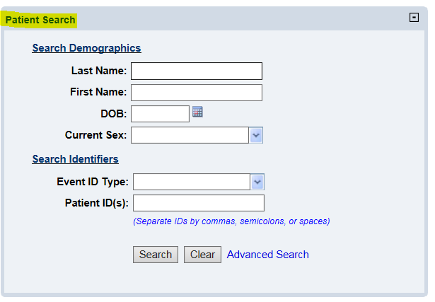

Files | NEDSSDashletTag.java
Code | Added tabIndex=”0” to <h2>: <h2 tabIndex=\"0\"

Notices, News and disabled Queues

- The notices section it was not read, so tabIndex=”0” was added to the id = ldfSection.
- Also, tabIndex=”0” was added to WHO Disease Outbreak News.
- The queues that don’t have any row are disabled. tabIndex=”0” has been added to them.
Files | HomePage.jsp
Code | $j(document).ready(function(){  $j("#DEM102").focus(); //set starting focus to last name  addTabIndexToReadOnly();  });  function addTabIndexToReadOnly(){  //TabIndex added to the Notices section  if(document.getElementById("ldfSection")!=null && document.getElementById("ldfSection").getElementsByTagName("tr").length>0)  document.getElementById("ldfSection").setAttribute("tabIndex","0");  else  if(document.getElementById("ldfSection")!=null)//There are no Notices available  document.getElementById("ldfSection").next().setAttribute("tabIndex","0");  //TabIndex added to the News section  if(document.getElementById("li0_1")!=null && document.getElementById("li0_1").getElementsByClassName("content")!=null &&  document.getElementById("li0_1").getElementsByClassName("content").length>0 && document.getElementById("li0_1").getElementsByClassName("content")[0].getElementsByTagName("b")!=null&&  document.getElementById("li0_1").getElementsByClassName("content")[0].getElementsByTagName("b").length>0)  document.getElementById("li0_1").getElementsByClassName("content")[0].getElementsByTagName("b")[0].setAttribute("tabIndex","0");  //My Queues  var lis = $j("#myQueues li");  for(var i=0; i<lis.length; i++){  if(lis[i].getElementsByTagName("a").length==0)  lis[i].setAttribute("tabIndex","0");  }  }

Queues in general

Files | Globals and also added to pages like patient_search_results.jsp
Code | Created new method addTabs which calls addTabIndexToCells and removeTabIndexFromImagesInsideLinks  function addTabIndexToCells(){  //it does not include cells with inputs (like checkboxes) or links because they are already getting the focus  $j(".dtTable td:not(:has(a)):not(:has(input[@type=checkbox])):not(:has(input[@type=button])):not(:has(img))").attr("tabIndex","0");  }  Call to that method from common JSP page:  topNavFullScreenWidht.jsp  function startCountdown() {  var sessionTimeout = <%= request.getSession().getMaxInactiveInterval()%>  min = sessionTimeout / 60;  sec = 0;  getTimerCountDown();  addTabIndexToCells();  }  /**  * removeTabIndexFromImagesInsideLinks: tabIndex="0" was added to all images. Some of them are inside links. For avoiding tab twice on the same element, in case there's an image inside a link, the tabIndex has been removed from the image.  */  function removeTabIndexFromImagesInsideLinks(){  var i=0;  var links = document.getElementsByTagName("a");  for (i=0; i<links.length; i++){  var images = links[i].getElementsByTagName("img");  if(images!=null && images.length>0){  var j=0;  for( j=0; j<images.length;j++){  images[j].removeAttribute("tabIndex");  }  }  }  }

Submit Icon on home page

Files | toolbarButton.xsl
Code | Added tabIndex=”0”  <xsl:attribute name="tabIndex">  <xsl:value-of select="'0'"/>  </xsl:attribute>  Added on keypress event:  <xsl:attribute name="onkeypress">  <xsl:value-of select="'if(is_ie){return id_UserName_onkeypress(this);}else{return id_UserName_onkeypress(event);}'"/>  </xsl:attribute>

Headers

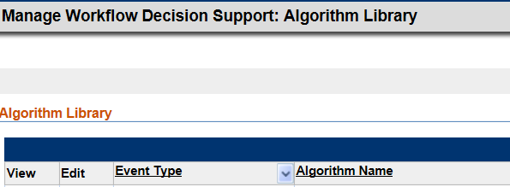

Files | NEDSSContainerTag.java
Method | renderContainerElement
Code | Change tabIndex= -1 to tabIndex = 0

Patient file

Files | View_Workup.jsp
Method | Created a new method (addTabsToPatientSummary) and called from the onload. Also AddTabs is called from onload.
Code | function addTabsToPatientSummary(){  //Patient file, first header table  $j("#Summary_summary td:not(:has(a)):not(:has(input[@type=checkbox])):not(:has(input[@type=button])):not(:has(input[@type=image])):not(:has(img))").attr("tabIndex","0");  }  <logic:equal name="viewEventsOnly" value="true">  <body onload="startCountdown1();handlePatExtendedBE();focusTab();autocompTxtValuesForJSP();tableCollapseEvent();fieldFocus();addTabs();addTabsToPatientSummary();">  </logic:equal>  <logic:notEqual name="viewEventsOnly" value="true">  <logic:equal name="DSPersonForm" property="actionMode" value="Edit">  <body onload="enableOrDisable('INV2002','ReasonUnknown','UNK');enableOrDisable('CurrSex','UnknownSpecify','U');startCountdown1();handlePatExtendedBE();autocompTxtValuesForJSP();handlebatchEntry();showHideSpanishOrigin();loadCounties();clearBatchEntryFields('nameTable');clearBatchEntryFields('addrTable');clearBatchEntryFields('phoneTable');clearBatchEntryFields('idenTable');clearBatchEntryFields('raceTable');document.location.href='#pageview';addTabs();">  </logic:equal>  <logic:notEqual name="DSPersonForm" property="actionMode" value="Edit">  <body onload="startCountdown1();handlePatExtendedBE();focusTab();autocompTxtValuesForJSP();tableCollapseSummary();tableCollapseEvent();handlebatchEntry();fieldFocus();addTabs();addTabsToPatientSummary();">  </logic:notEqual>  </logic:notEqual>

View Investigation

To be able to tab throught each of the read only fields in View investigation tab, a new rule has been added to the addTabIndexToCells method in Globals.js. Also AddTabs() (the parent method) has been added to each of onload in the DMB* files.
Files | Globals.js
Method | addTabIndexToCells
Code | function addTabIndexToCells(){  //it does not include cells with inputs (like checkboxes) or links because they are already getting the focus  $j(".dtTable td:not(:has(a)):not(:has(input[@type=checkbox])):not(:has(input[@type=button])):not(:has(input[@type=image])):not(:has(img))").attr("tabIndex","0");  //For patient file tables  $j(".bluebardtTable td:not(:has(a)):not(:has(input[@type=checkbox])):not(:has(input[@type=button])):not(:has(input[@type=image])):not(:has(img))").attr("tabIndex","0");  //add tabIndex to filter icon  $j(".multiSelect").attr("tabIndex","0");  //Read only text, like Investigation view  $j(".subSect td").attr("tabIndex","0");  }

Class Notab

A new class has been added in order to avoid to tab to empty td created within the page:
<td class="noTab">
From Globals.js, the method addTabIndexToCells skips those with class = “noTab”

Class tabIndexClass

It was found an issue regarding to the following rule:
$j(".subsect td:not(:has(input)):not(.noTab)").attr("tabIndex","0");
This rule was added to be able to tad through labels in pages like View investigation. Because some pages also have the class subsect but they have labels and input text, we were tabbing trough both of them. We are not supposed to tab to labels if there are input boxes. In order to fix that, the rule has been changed to:
$j(".tabIndexClass td:not(:has(input)):not(.noTab)").attr("tabIndex","0");
And in the DMB_generate_View_index_Jsp.xsl, the class tabIndexClass has been added to the body. That way, that rule only affects to View investigations pages. The class will be added to any other necessary page.

INCONSISTENT COMBOBOX

Issue: the dropdown in charts was looking different than the rest of the dropdowns in the system
Solution: dropdown changed to look like the rest of dropdowns removing the attribute acomplete=”false”. JavaScript functionality added to trigger getChart when up and down rows are pressed and divs with display:inline-block have been added to move the magnify icon next to the dropdown.
Files | Charts.jsp
Code | <div style="white-space: nowrap; display:inline-block">  <div style="display:inline-block">  <html:select name="homepageForm" property="attributeMap.currentChart" styleId="charts" onchange="getChart();" title="Select the chart to display">  <html:optionsCollection property="chartList" value="key" label="value"/>  </html:select>  </div>  <div style="display:inline-block">  <img id="magnify" src="magnify.jpg" title="Magnify" alt="Magnify" onclick="javascript:getPopupChart();" style="cursor: pointer;text-decoration:none; float:right"/>  </div>

EMPTY LINKS

Empty links in section
Issue: in case there’s an empty link within the page, wave was showing errors. That happens when defaultDisplay = F.
Solution: add a hidden link with a text.

Files | NedssContainerTag.java
Method | renderContainerElement
Code | Added:  if((defaultDisplay!=null && defaultDisplay.equalsIgnoreCase("F"))){  sb.append("<a style=\"display:none\" class=\"toggleHref\" href=\"#\" tabindex=-1 onclick=\"return toggleAllSubSectionsDisplay('");  sb.append(this.id).append("');\">");  sb.append("Hidden Link");  sb.append("</a>");  }

Empty link in page

Issue: it was found some empty links within the pages.
Solution: this seems to be a prior issue so the same solution that was applied before has been applied in this case.

Files | nedss.css
Code | #patientSearchByEvent .subSectionsToggler{  display:none;  }

TABLES LAYOUT

Issue: According to CDC feedback, tables shouldn’t be used as layout. Tables should only be used to represent data. In order to fix this, role=presentation has been added to those tables which purpose is not representing data.
Solution: most of the tables have been updated to look like:
<table role = “presentation” in different type of files, like JSP, XSL or Java.

Regular tables

Tables with role = “presentation”

The tables that have been updated to add the role = “presentation” are:
- Tables with class = sectionsToggler
- Tables with class = formTable
- Tables which purpose is not representing data
The solution has been applied to the corresponding files. Also, the
bluebarTag.java which generates sections and subsections with tables (like the ones in Patient file) has been updated to include the attribute role = “presentation” to the tables with class = bluebarsectHeader and class = bluebarsubSect.

Tables without role = “presentation”

- Tables with class = dtTable
- Tables created from display:table
- Tables that clearly are defining data tables with th, tr and td.

Tables generated from <layout:tabs>

The struts library struts-layout-1.2.jar creates tabs that we are using in the application. Those tabs consist of tables, which need the role = “presentation” attribute. In order to not modify the library, the following method has been added to the Globals.js file:

addRolePresentationToTabsAndSections.

This method is called from the templates that generate the page builder investigations, topNavFullScreenWidth.jsp file, as well as other files like patient_search_criteria_by_event, popup files, etc.
The method addRoleToPatientFile is a new method called from patient file for adding the role = “presentation” to some empty tables.

ADDITIONAL FUNCTIONALITY

Files | Globals.js
Code | BlockEnterKey is a method that was created some time ago to be used across the different pages. It help avoid enter key on element that are not supposed to do anything and allow enter key in submit buttons, links or other type of elements.

